- Tên và phân loại:
Given a language, define a representation for its grammar along with
an interpreter that uses the representation to interpret sentences in
the language
- Mục đích, ý nghĩa:

- Động lực sử dụng:
- When a program presents a number of different but somewhat similar cases it
can deal with, it can be advantageous to use a simple language to describe
these cases and then have the program interpret that language. Such cases
can be as simple as the sort of Macro language recording facilities a number
of office suite programs provide or as complex as Visual Basic for Applications
(VBA). VBA is not only included in Microsoft Office products, but it can be
embedded in any number of third-party products quite simply
- One of the problems we must deal with is how to recognize when a language
can be helpful. The Macro language recorder simply records menu and
keystroke operations for later playback and just barely qualifies as a language;
it may not actually have a written form or grammar. Languages such as VBA,
on the other hand, are quite complex, but they are far beyond the capabilities
of the individual application developer. Further, embedding commercial
languages usually require substantial licensing fees, which makes them less
attractive to all but the largest developers
- Khi nào sử dụng:
- The grammar is simple
• For complex grammars, the class hierarchy for the grammar
becomes large and unmanageable. Tools such as parser
generators are a better alternative in such cases. They can
interpret expressions without building abstract syntax trees, which
can save space and possibly time

- Efficiency is not a critical concern
• The most efficient interpreters are usually not implemented by
interpreting parse trees directly but by first translating them into
another form. For example, regular expressions are often
transformed into state machines. But even then, the translator
can be implemented by the Interpreter pattern, so the pattern is
still applicable
- Cấu trúc
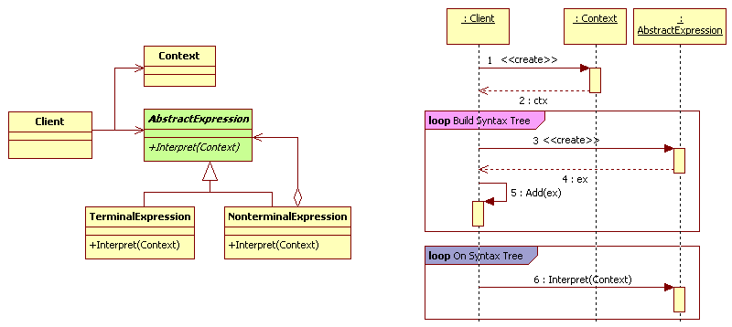
- Các thành viên - Sự cộng tác
- AbstractExpression: declares an abstract Interpret operation
that is common to all nodes in the abstract syntax
- Context: contains information that's global to the interpreter
- TerminalExpression
• Implements an Interpret operation associated with terminal symbols in the
grammar
• An instance is required for every terminal symbol in a sentence

- NonterminalExpression
• One such class is required for every rule R ::= R1 R2 ... Rn in the grammar
• Maintains instance variables of type AbstractExpression for each of the
symbols R1 through Rn
• Implements an Interpret operation for non-terminal symbols in the
grammar. Interpret typically calls itself recursively on the variables
representing R1 through R

- Client
• Builds an abstract syntax tree representing a particular sentence in the
language that the grammar defines. The abstract syntax tree is assembled
from instances of the NonterminalExpression and TerminalExpression classes
• Invokes the Interpret operation
- Các hệ quả mang lại:
- Easy to change and extend the grammar
• Because the pattern uses classes to represent grammar rules, you can use
inheritance to change or extend the grammar
• Existing expressions can be modified incrementally, and new expressions
can be defined as variations on old ones

- Implementing the grammar is easy, too
• Classes defining nodes in the abstract syntax tree have similar
implementations. These classes are easy to write, and often their
generation can be automated with a compiler or parser generator

- Complex grammars are hard to maintain
• Defines at least one class for every rule in the grammar
• Hence grammars containing many rules can be hard to manage and
maintain. Other design patterns can be applied to mitigate the problem.
But when the grammar is very complex, other techniques such as parser
or compiler generators are more appropriate

- Adding new ways to interpret expressions
• Makes it easier to evaluate an expression in a new way. For example, you
can support pretty printing or type-checking an expression by defining a
new operation on the expression classes. If you keep creating new ways
of interpreting an expression, then consider using the Visitor pattern to
avoid changing the grammar classes
- Chú ý liên quan đến cài đặt:

- Hệ thống thực tế

- Mẫu liên quan
- Composite: The abstract syntax tree is an instance of the
Composite pattern
- Flyweight: shows how to share terminal symbols within the
abstract syntax tree
- Iterator: The interpreter can use an Iterator to traverse the
structure
- Visitor: can be used to maintain the behavior in each node in
the abstract syntax tree in one class

